|  |  |  |  |  |  |
| --- | --- | --- | --- | --- | --- |
| **Group No** | CS 30 | | | | |
| **Project Title** | E-Commerce site for Apparels (Tentative) | | | | |
| **Supervisor’s Name** | Mr. Tharindu Wijethileke | | | | |
| **Co-Supervisor’s Name** | Miss. Sithara Fernando | | | | |
| **Group Meeting Number** | 01 | **Date** | | 28/05/2021 | |
| **Summary of work carried out during last two weeks** | | | | | |
| Since this is the initialization of the project, the first 2 weeks were spent on gathering and analyzing ideas for the project. The basic technologies that are to be used during the project were learnt by each team member.   1. The initial meeting was taken by the supervisor and four team members on 21st of May. Initial thoughts on project ideas of each team member were proposed in the meeting. 2. Requirements of few selected ideas were listed down to gain a clear image on each of them. At the same time new ideas were also taken into consideration. 3. In the 2nd meeting with the supervisor which was taken on 28th May, the listed down requirements were discussed. Scope of the ideas were analyzed and modifications to be done were identified. | | | | | |
| **Individual Contribution for last two weeks** | | | | | |
| 1. N.D.Dissanayake   19000413 | * Ideas for the project were collected by going through previous projects and examining problems we face day-to-day life. * Came up with some ideas which were later discussed in the supervisor meeting. * Requirements of ideas were listed down to get a better picture of the scope together with all team members. * Learning basic Git commands and about the MVC architecture. | | | | |
| 1. R.M.N.T.S.Rajapaksha   19001274 | * Gathered new ideas and features related to introduced ideas by analyzing existing projects and platforms. * Searched information about new technologies and applications related to future works. * Worked on web development technologies (HTML, CSS, JavaScript). | | | | |
| 1. K.P.R.L.Madhubhashana   19000812 | * Gathered some new information and ideas related the project. * Visit several websites related to our project ideas and analyzed their features. * Collected requirements related to our project ideas and created reports to identify the scope of each idea. * Learning basics of HTML, CSS and PHP. | | | | |
| 1. H.D.R.M.Munasinghe   19001029 | * Suggested few ideas for the group project. * Browsed existing software related to the suggested ideas and gathered requirements related to each of them. * Discussed how to expand the scope of each project idea by adding new functionalities. * Start to learn web development technologies. | | | | |
| **Meeting outcomes** | | | | | |
| * Discussing about initial project ideas and their scopes. Selected few best ideas from them. * Discussing about the flow of the project and future works with the supervisor. * Going through the requirements listed down and identified the areas that can be improved and the new functionalities that can be added to each idea. * Discussing practical issues and business values related to each idea. * Identifying different technologies and applications which are to be used during the project.   + Supervisor advised us to use GitHub repository from the initial stages.   + Also advised us to use Trello (a project management tool) to collaborate with each other in an effective manner. * Receiving instructions to use a standard format (such as IEEE format) in the SRS documentation. | | | | | |
| **Responsibilities Accepted by group members for the next two weeks** | | | | | |
| 1. N.D.Dissanayake   19000413 | * Doing a research on what technologies to be used for the system development. * Getting hands-on experience on Trello & Git. * Take initiative to learn JavaScript and PHP. | | | | |
| 1. R.M.N.T.S.Rajapaksha   19001274 | * Gather more requirements, functionalities for introduced ideas. * Learn HTML, CSS, JavaScript. * Search new technologies related to future works (Git, Trello, etc.) | | | | |
| 1. K.P.R.L.Madhubhashana   19000812 | * Collect some new ideas with functionalities. * Learn HTML, CSS and JS. | | | | |
| 1. H.D.R.M.Munasinghe   19001029 | * Learn web development technologies. * Gather new requirements to improve our ideas. | | | | |
| **Any Other Notes** | | | | | |
| * First Meeting – Zoom Link      * Second Meeting - Zoom Link      * Currently we have mainly discussed two project ideas with our supervisor, and also one idea which is yet to be proposed in the next meeting. We are hoping to finalize on a project next Friday (4th June). | | | | | |
| **Attendance of the group members** | | | | | |
| **Student Name** | | | **Index No.** | | **Signature** |
| 1). N.D.Dissanayake | | | 19000413 | |  |
| 2). R.M.N.T.S.Rajapaksha | | | 19001274 | |  |
| 3). K.P.R.L.Madhubhashana | | | 19000812 | |  |
| 4). H.D.R.M.Munasinghe | | | 19001029 | |  |

**Group Members**

* N.D.Dissanayake

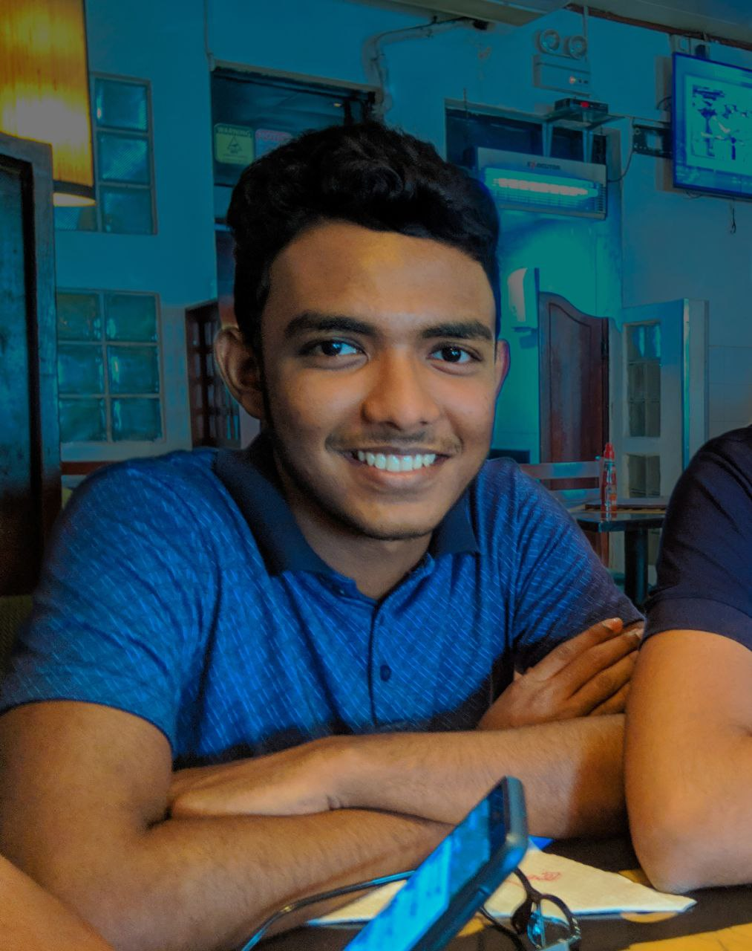

* R.M.N.T.S.Rajapaksha

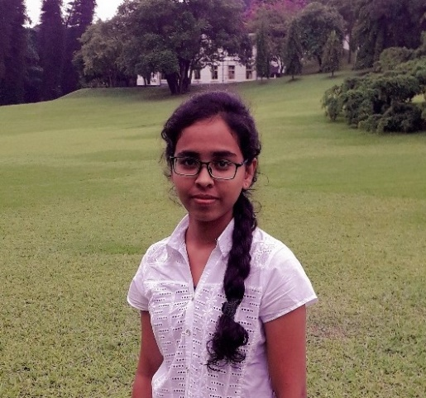

* K.P.R.L.Madhubhashana

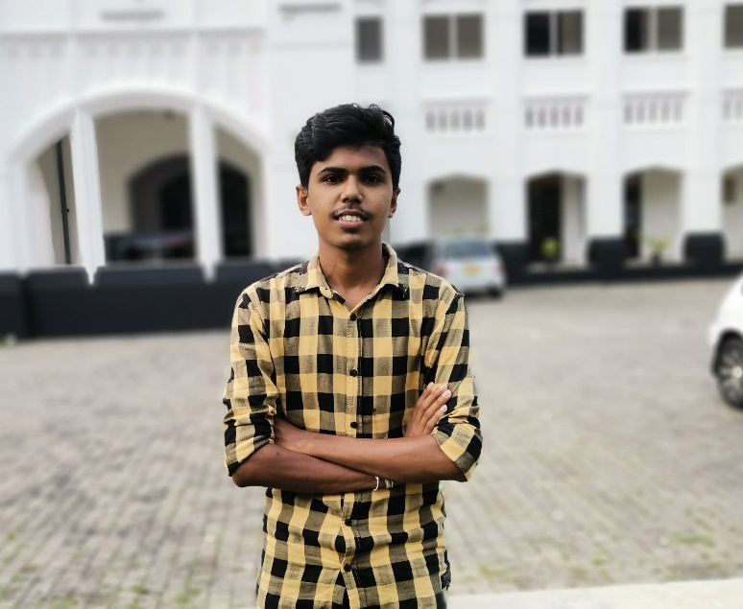

* H.D.R.M.Munasinghe

